Predefined Functional Interfaces
Java.util.function package provides below predefined functional interfaces.
- Predicate
- Function
- Consumer
- Supplier
Etc.,
Predicate: (A Boolean valued functional interface)
Returns Boolean based on a conditional check.
Ex: if an employee salary is greater that 10000 or not, age greater that 18 or not
Contains one abstract method:
Interface Predicate<T>{
boolean test(T t)
}

Usage:
We can use predicate to refer lambda expression.

Normal Method | Lambda Expression | Using Predicate – Invoking lambda Expression Using Predicate
Public void Boolean test (Integer I){  If(I>10) { return true; }  else { return false; }  } | (Integer I) -> {  If(I>10) { return true; }  else { return false; }  }  Simplified:  I -> I>10; | Predicate<Integer> P = I -> i>10;  Sop(p.test(100)); - true  Sop(p.test(5)); - false

Example 1:
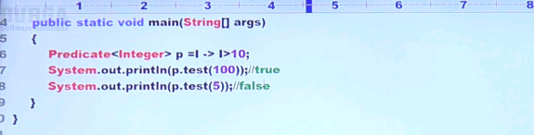

Example 2:
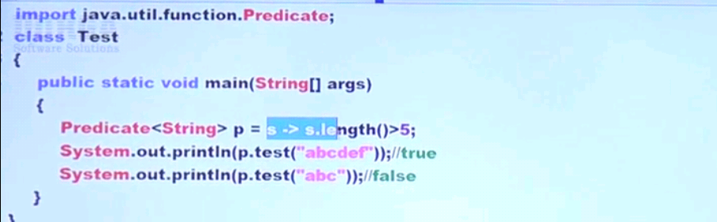

Example 3:
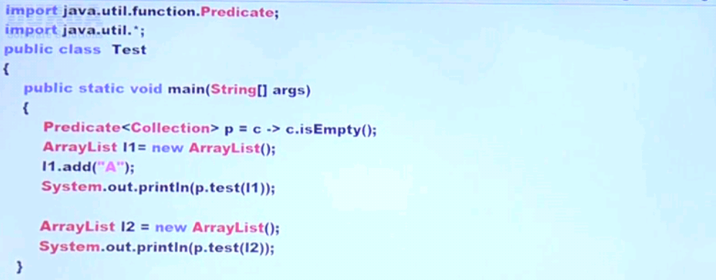

Predicate Joining:

Joining multiple predicates into single predicate.

P1 : predicate checks given number greater than 10.
P2 : predicate checks given no is even

Compliment of P1:
P1.negate() -> predicate checks given no is not greater than 10

AND Operation:
P1.and(P2) -> predicate checks given no is greater than 10 and even
OR Operation:
P1.or(p2) -> predicate checks given is greater than 10 or even

Above said negate(), and(), or() are default methods of Predicate Interface.
Predicate contains a static method called isEquals() to check a given predicate is equal or not. -> See example last

Example:

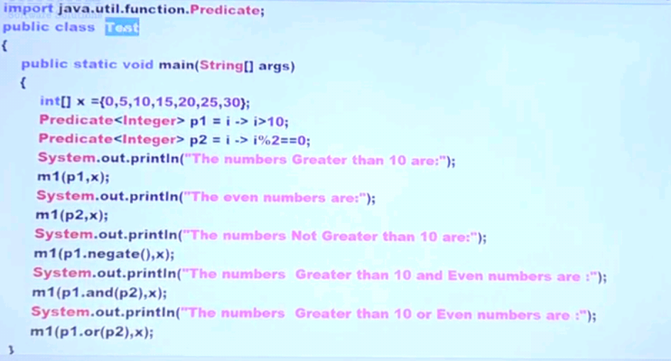
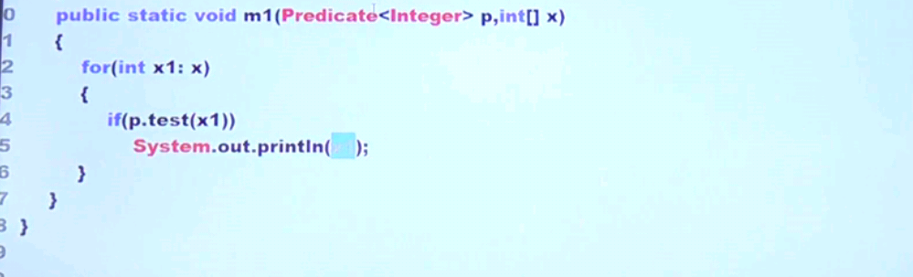

Example: Program to display names starts with K using Predicate
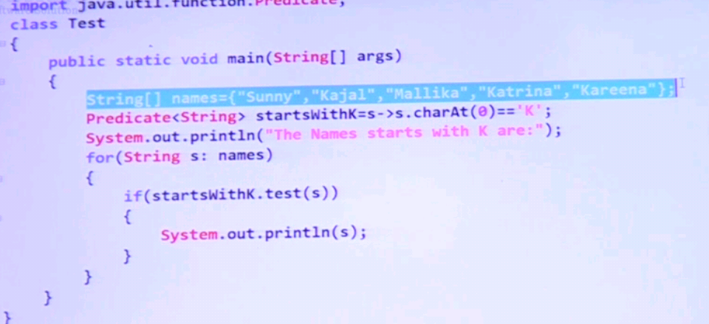

Example – to remove null values and empty string from the List
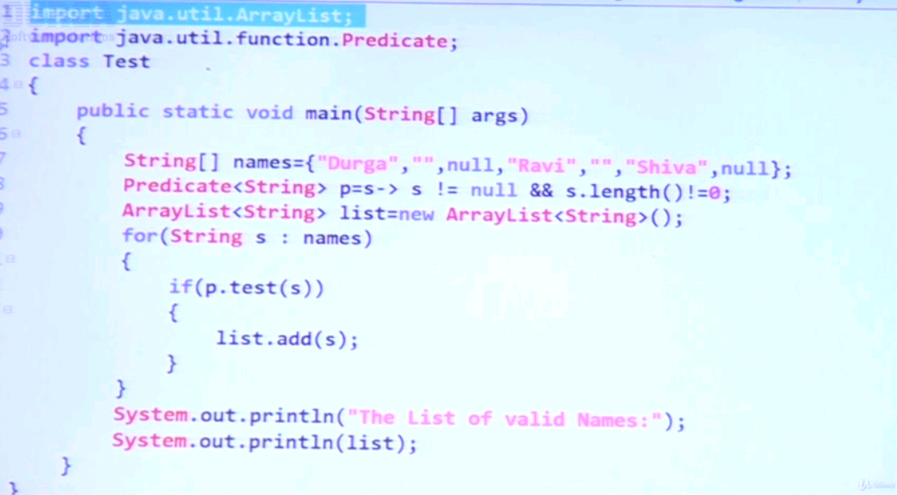

Example – program for user authentication
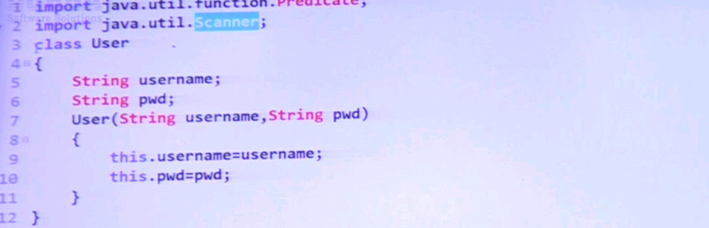
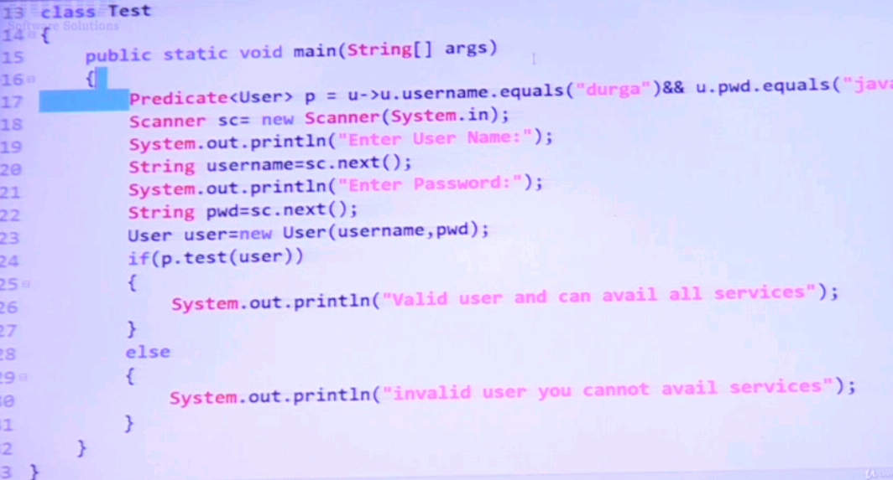

Example – Program to check whether software engineer is allowed into Pub or not
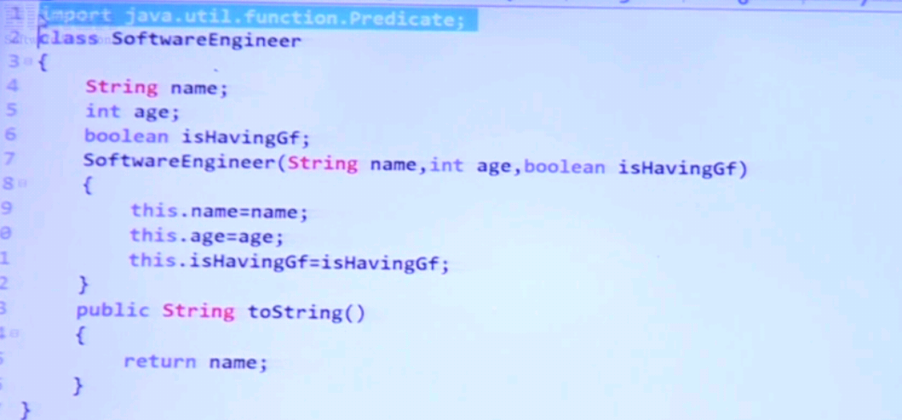
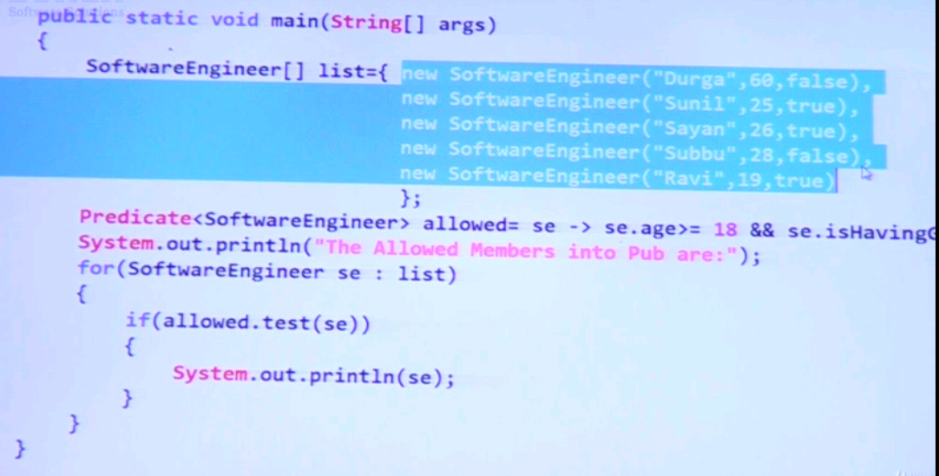

Employee Management Application Using Predicates:
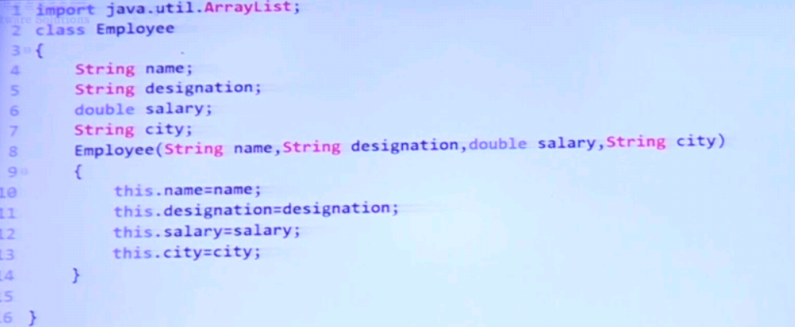

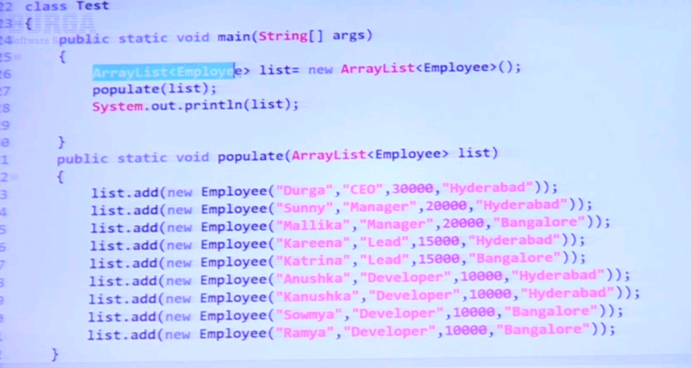

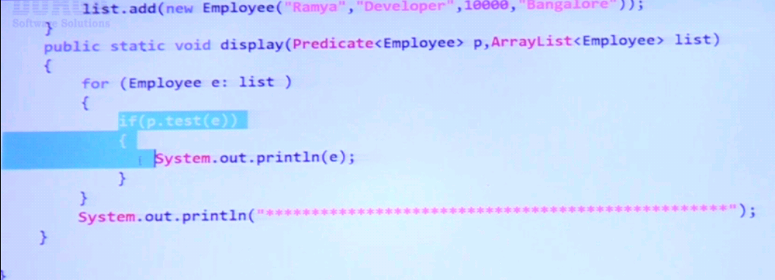

Predicates test for above:
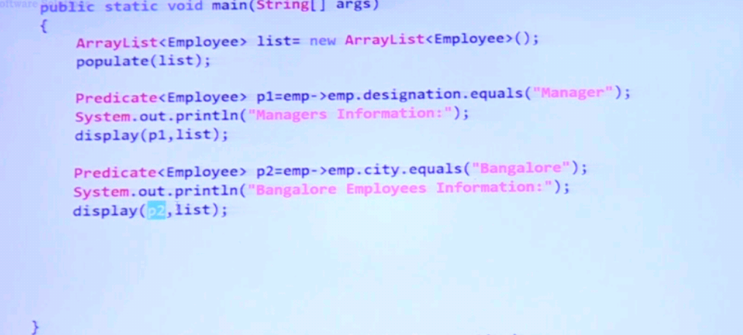
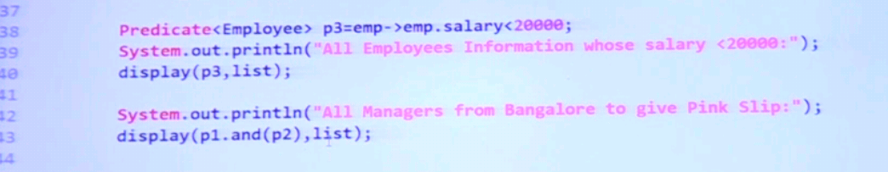
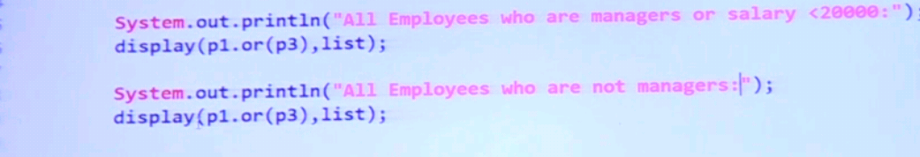

Predicate – static method isEquals()
Example Using String:
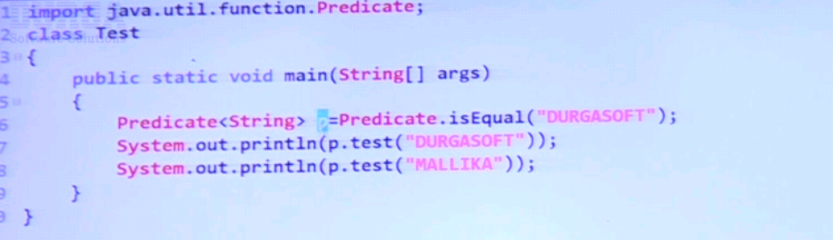
Example using Custom Class
